## **Part 1: Cyber Security and SEIM using QRADAR Report**

1. Overview

Finding potential vulnerabilities in the online application was the goal of the audit. Unauthorized access, problems with configuration management, information leakages, and other flaws were among the web application's vulnerabilities that were tested. Testing on a black box was carried out.

The test only included web applications; it excluded host servers or network-related problems. We have researched cross-site scripting, a practice where malicious data is introduced between reputable websites.

Apart from our standard security assessment practices, we performed general review of applications and the same is provided in our reporting format. Below gives the glance of complete sections of our security assessment, where for this report we are highlighting the findings as below.

|  | Name of the vulnerability | Reference -CWE |
| --- | --- | --- |
| 1 | **Broken Access Control** | CWE -284 Improper Access Control |
| 2. | Cryptographic Failures | CWE-327: Use of a Broken or Risky Cryptographic Algorithm |
| 3 | Injection | |  |  | | --- | --- | | CWE-89: Improper Neutralization of Special Elements used in an SQL Command ('SQL Injection') | |
| 4 | Insecure Design | CWE-657:Violation of Secure Design Principles |
| 5 | Security Misconfiguration | CWE-16 **Configuration** |
| 6 | Vulnerable and Outdated Components | CWE-1104: Use of Unmaintained Third Party Components |
| 7 | [Identification and Authentication Failures](https://owasp.org/Top10/A07_2021-Identification_and_Authentication_Failures/) | [CWE-287: Improper Authentication](https://cwe.mitre.org/data/definitions/287.html) |
| 8 | Software and Data Integrity Failures | CWE-494 :Download of Code without Integrity Check |
| 9 | Security Logging and Monitoring Failures | **CWE-532** [Insertion of Sensitive Information into Log File](https://cwe.mitre.org/data/definitions/532.html) |
| 10 | Server-Side Request Forgery (SSRF) | **CWE-918**  Request Forgery attack (SSRF) |

2..

1.Vulnerability Name :Broken Access control

CWE : CWE-284 Improper Access Control

OWASP Category: A01:2021

DESCRIPTION: The restriction of access is less it provide easily access without many restrictions

Business Impact: In business its access can be very devastated for the user as it can easily give access to hacker which can change or delete accounts.

2.Vulnerability Name :Cryptographic Failures

CWE : CWE-327 Use of a Broken or Risky Cryptographic Algorithm

OWASP Category: A02:2021

DESCRIPTION:  Using such an algorithm means that an attacker may be able to easily decrypt the encrypted data.

Bussiness Impact: Attempting to create non-standard and non-tested algorithms, using weak algorithms, or applying algorithms incorrectly will pose a high weakness to data that is meant to be secure.

3.Vulnerability Name: Injection

CWE : CWE-89: Improper Neutralization of Special Elements used in an SQL Command ('SQL Injection')

OWASP Category: A03:2021

DESCRIPTION:  Using such an algorithm means that an attacker may be able to easily decrypt the encrypted data.

Bussiness Impact:The unauthorized viewing of user lists, the deletion of entire tables and, in certain cases, the attacker gaining administrative rights to a database, all of which are highly detrimental to a business.

4.Vulnerability Name:Insecure Design

CWE : CWE-657:Violation of Secure Design Principles

DESCRIPTION:  It is related to critical design and architectural flaws in web applications that hackers can exploit.

Bussiness Impact: Failing to do so can lead to flaws that threaten your organizational security, compromising sensitive data, granting privileges to individuals who can abuse them, and more.

5.Vulnerability Name: Security Misconfiguration

CWE : CWE-16 Configuration

DESCRIPTION:  A security misconfiguration occurs when system or application configuration settings are missing or are erroneously implemented, allowing unauthorized access.

Bussiness Impact: Security misconfigurations allow attackers to gain unauthorized access to networks, systems and data, which in turn can cause significant monetary and reputational damage to your organization.

**6** Vulnerability Name: Vulnerable and Outdated Components

CWE : CWE-1104

OWASP Category: A06:2021

Description: Use of Unmaintained Third Party Components

Business Impact: The product relies on third-party components that are not actively supported or maintained by the original developer or a trusted proxy for the original developer.

Using vulnerable and outdated components is the sixth category in OWASP Top 10 web application security risks and one of the most common and serious mistakes developers and companies make. It can lead to devastating consequences such as data breaches, malware infections, and compromised systems.

* 7.Vulnerability Name:  [Identification and Authentication Failures](https://owasp.org/Top10/A07_2021-Identification_and_Authentication_Failures/)

CWE : [CWE-287 Improper Authentication](https://cwe.mitre.org/data/definitions/287.html)

OWASP Category: A06:2021

Description: When an actor claims to have a given identity, the product does not prove or insufficiently proves that the claim is correct.

Business Impact: Improper authentication can lead to various security threats, such as: Data breaches: Improper authentication can allow unauthorized users to gain access to sensitive data, leading to data breaches, data loss, or unauthorized access to confidential information.

# 8. Vulnerability Name: Software and Data Integrity Failures

CWE : CWE-494

OWASP Category: A06:2021

Description: Download of Code without Integrity Check

Business Impact: The product downloads source code or an executable from a remote location and executes the code without sufficiently verifying the origin and integrity of the code.

# 9 Vulnerability Name: Security Logging and Monitoring Failures

CWE : CWE-532

OWASP Category: A06:2021

Description:  [Insertion of Sensitive Information into Log File](https://cwe.mitre.org/data/definitions/532.html)

Business Impact: Information written to log files can be of a sensitive nature and give valuable guidance to an attacker or expose sensitive user information. Sensitive data exposure can be financially costly to your business and damage your reputation and brand. The type of data at risk of exposure includes financial reports, bank account numbers, credit card numbers, usernames, passwords, customers' personal details, and healthcare information.

# 10. Vulnerability Name: Server-Side Request Forgery (SSRF)

CWE : CWE-918

OWASP Category: A06:2021

Description: The web server receives a URL or similar request from an upstream component and retrieves the contents of this URL, but it does not sufficiently ensure that the request is being sent to the expected destination. A Server-Side Request Forgery attack (SSRF) is a security vulnerability in which a hacker tricks a server into accessing unintended resources on his behalf. An SSRF attack can lead to sensitive information being leaked or the attacker gaining control of other systems.

Business Impact: In some situations, the SSRF vulnerability might allow an attacker to perform arbitrary command execution. An SSRF exploit that causes connections to external third-party systems might result in malicious onward attacks that appear to originate from the organization hosting the vulnerable application.

**TEAM MEMBERS INVOLVED IN VULNERABILITY ATTACKS**

| **S.NO.** | **NAME** | **DESIGNATION** | **MOBILE NUMBER** |
| --- | --- | --- | --- |
|  | **Er. Hemlata** | **Assistant Professor** | **8171552621**  **hemlata.gangwar@srmscet.edu** |
| **2.** | **Er. Anjali Arora** | **Assistant Professor** | **9871005528**  **anjali.arora@srmscet.edu** |
| **3.** | **Dr. Jyoti Agarwal** | **Associate Professor** | **9412655605**  **jyoti.agarwal@srmscet.edu** |
| **4.** | **Er. Anu Saxena** | **Assistant Professor** | **7611001926**  **anu.saxena@srmscet.edu** |

**Stage: 2 Report**

**Introduction to Nessus**

Nessus is a network vulnerability scanner that utilizes the Common Vulnerabilities and Exposures engineering for simple cross-connecting between agreeable security instruments. Nessus utilizes the Nessus Attack Scripting Language (NASL), a basic language that portrays singular dangers and potential assaults. Nessus has a measured design comprising of incorporated servers that direct examining, and remote customers that take into account chairman communication. Executives can incorporate NASL portrayals of every presumed powerlessness to create altered outputs. Noteworthy abilities of Nessus include:

* Compatible with all OS
* Scans for vulnerabilities in the local and remote host
* Informs about missing security in detail
* Applies various attacks in order to pinpoint a vulnerability
* It can schedule security audits
* Runs security tests

Nessus can scan these vulnerabilities and exposures:

* Vulnerabilities that could allow unauthorized control or access to sensitive data on a system
* Misconfiguration (e.g. open mail relay)
* Denials of service (Dos) vulnerabilities
* Default passwords, a few common passwords, and blank/absent passwords on some system accounts

Software flaws, missing patches, malware and misconfiguration errors across a wide range of operating systems, devices and applications are dealt with by Nessus.

The Nessus server is currently available for:

* Unix
* Linux
* FreeBSD

Also, the client is available for:

* Unix-based operating systems
* Windows-based operating systems

Significant capabilities of Nessus include:

* Scheduled security audits
* Detection of security holes in local or remote hosts
* Simulated attacks to pinpoint vulnerabilities
* Detection of missing security updates and patches
* Nessus Professional perform internal network scans as required by the PCI DSS 11.2.1 requirement.

The results of the scan can be reported in various formats, such as plain text, XML, and HTML.

You cannot use Nessus on a system with a Host-based Intrusion Prevention System (HIPS) installed. Because during the process of scanning a remote target, Nessus must forge TCP/UDP packets and send probes that are often considered “malicious” by HIPS software. If the HIPS system is configured to block malicious traffic, it will interfere with Nessus and cause the scan results to be incomplete or unreliable.

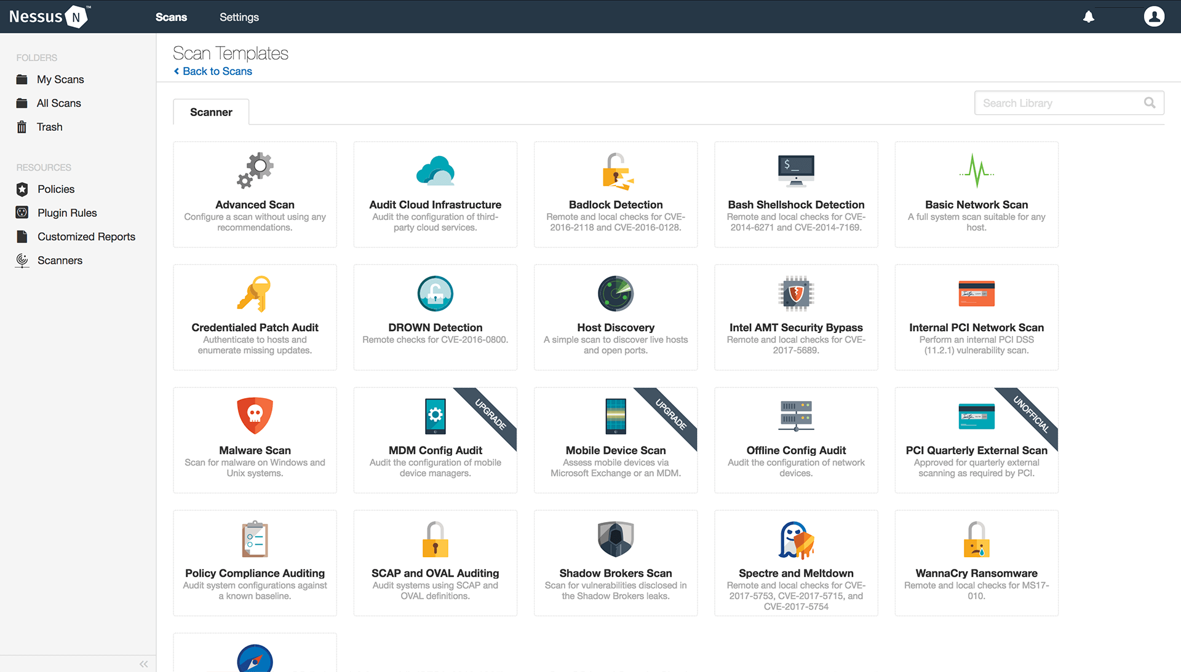

## Vulnerability Scanning with Nessus

Nessus performs its scans by utilizing plugins, which run against each host on the network in order to identify vulnerabilities. For instance, a plugin could be launched and targeted at a host to:

* Identify which operating systems and services are running on which ports
* Identify which software components are vulnerable to attacks (FTP, SSH, SMB and more)

The steps that are followed during scanning are:

* Define scan parameters
* Create scan
* Launch scan
* Analyze scan results

Once all the steps are complete, Nessus runs each host against a database of known vulnerabilities in an attempt to discover which host contains which vulnerabilities.

Ports can be defined in ranges or individually, with valid ports ranging from 1 to 65535.

Nessus gives you the ability to configure your scan based on different scan and policy templates. These templates will determine the settings that will be found within the scan policy settings:

* **Basic**: With this setting, you can specify security-related and organizational aspects of the scan or policy, such as name of the scan, the targets of the scan, whether or not it is scheduled and who has access to it.
* **Discovery**: For defining the ports to be scanned and the methods to be used while conducting this discovery.
* **Assessment**: This setting allows you to determine the type of vulnerability scan to perform and how they are performed.
* **Report**: For determining how scan reports are generated and the information that should be included within them.
* **Advanced**: Here you will define scan efficiency and the operations that the scan should perform.

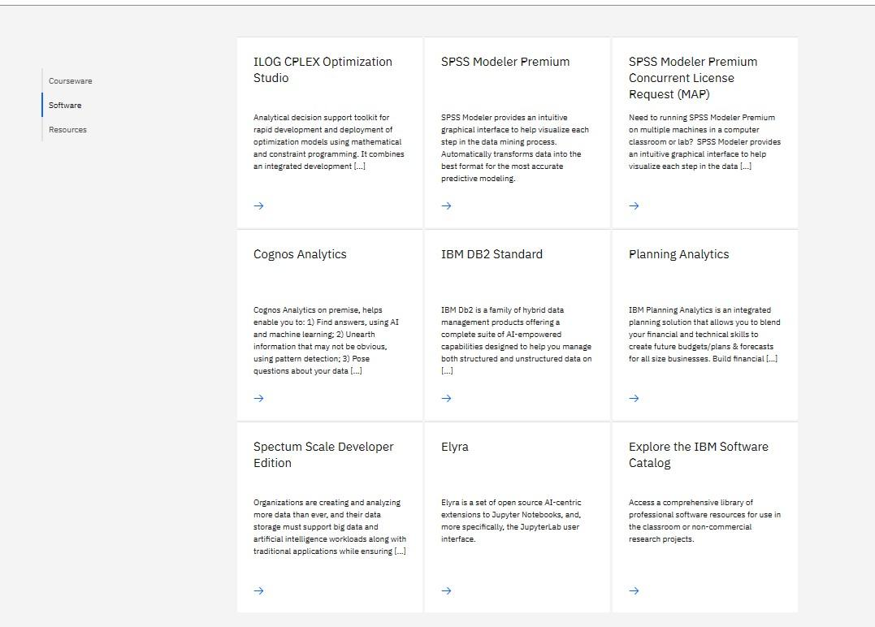

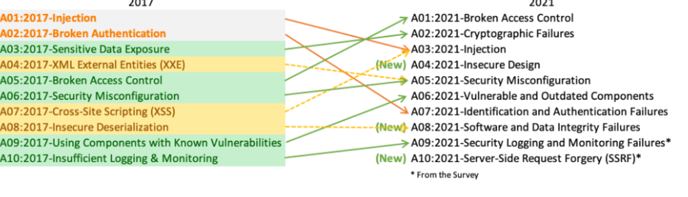

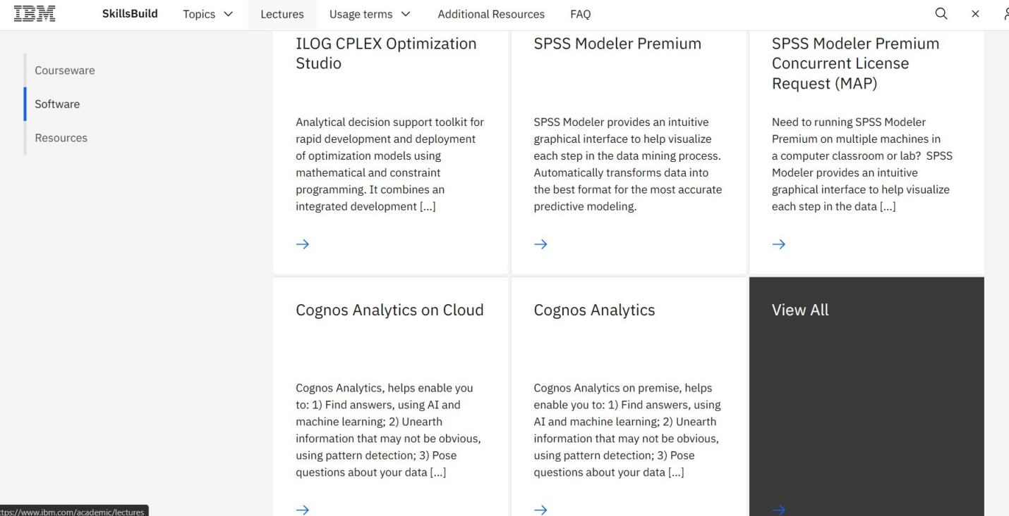

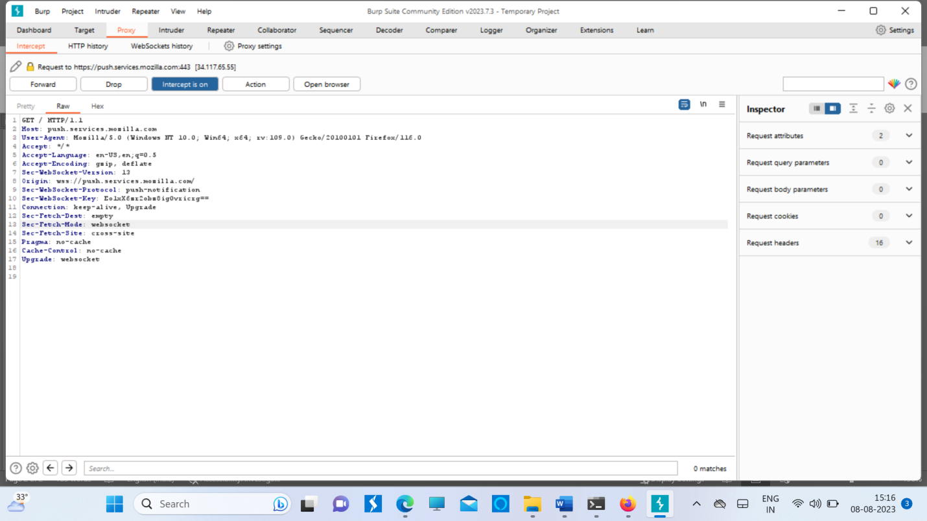

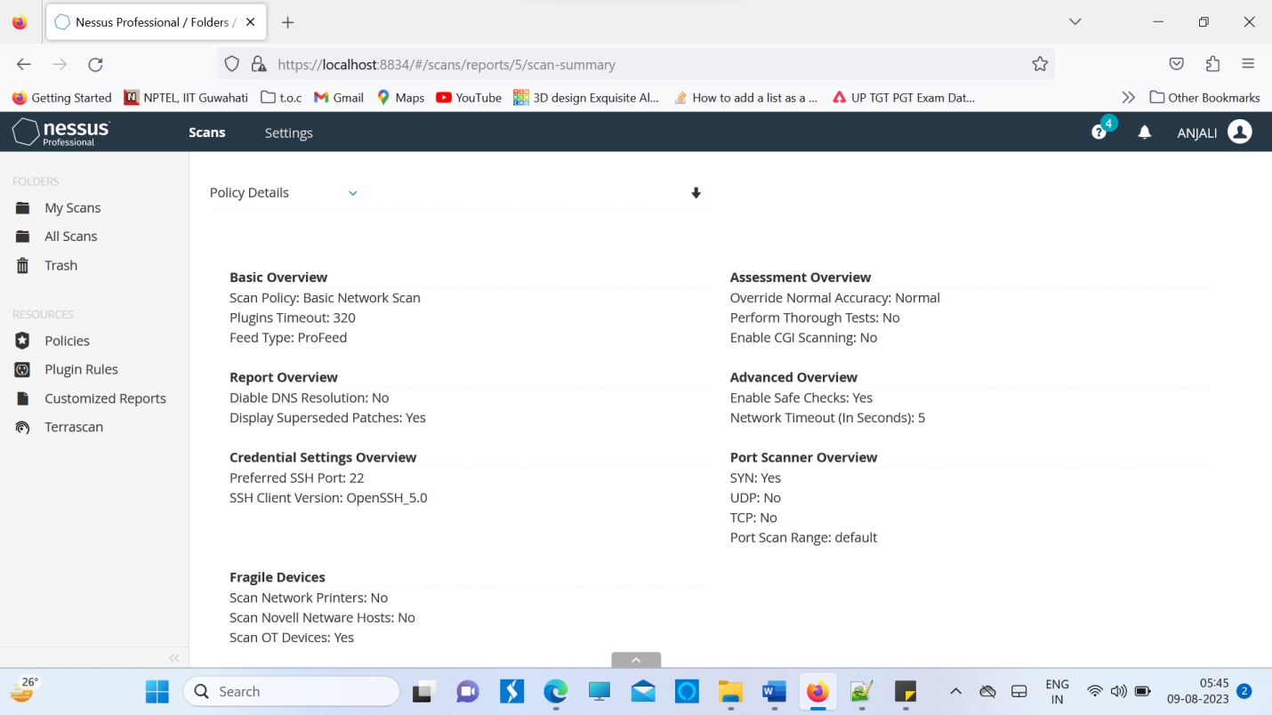

**Target WebSite : KG REDDY Engineering College website : kgr.ac.in**

| Plugin ID | Risk | Host | Protocol | Port | Name | Synopsis | Description | Solution |
| --- | --- | --- | --- | --- | --- | --- | --- | --- |
| 10107 | None | 99.84.238.218 | tcp | 80 | HTTP Server Type and Version | A web server is running on the remote host. | This plugin attempts to determine the type and the version of the  remote web server. | n/a |
| 10107 | None | 99.84.238.218 | tcp | 443 | HTTP Server Type and Version | A web server is running on the remote host. | This plugin attempts to determine the type and the version of the  remote web server. | n/a |
| 10287 | None | 99.84.238.218 | udp | 0 | Traceroute Information | It was possible to obtain traceroute information. | Makes a traceroute to the remote host. | n/a |
| 11219 | None | 99.84.238.218 | tcp | 80 | Nessus SYN scanner | It is possible to determine which TCP ports are open. | This plugin is a SYN 'half-open' port scanner. It shall be reasonably quick even against a firewalled target.   Note that SYN scans are less intrusive than TCP (full connect) scans against broken services, but they might cause problems for less robust firewalls and also leave unclosed connections on the remote target, if the network is loaded. | Protect your target with an IP filter. |
| 11219 | None | 99.84.238.218 | tcp | 443 | Nessus SYN scanner | It is possible to determine which TCP ports are open. | This plugin is a SYN 'half-open' port scanner. It shall be reasonably quick even against a firewalled target.   Note that SYN scans are less intrusive than TCP (full connect) scans against broken services, but they might cause problems for less robust firewalls and also leave unclosed connections on the remote target, if the network is loaded. | Protect your target with an IP filter. |
| 11936 | None | 99.84.238.218 | tcp | 0 | OS Identification | It is possible to guess the remote operating system. | Using a combination of remote probes (e.g., TCP/IP, SMB, HTTP, NTP, SNMP, etc.), it is possible to guess the name of the remote operating system in use. It is also possible sometimes to guess the version of the operating system. | n/a |
| 12053 | None | 99.84.238.218 | tcp | 0 | Host Fully Qualified Domain Name (FQDN) Resolution | It was possible to resolve the name of the remote host. | Nessus was able to resolve the fully qualified domain name (FQDN) of the remote host. | n/a |
| 19506 | None | 99.84.238.218 | tcp | 0 | Nessus Scan Information | This plugin displays information about the Nessus scan. | This plugin displays, for each tested host, information about the scan itself :   - The version of the plugin set.  - The type of scanner (Nessus or Nessus Home).  - The version of the Nessus Engine.  - The port scanner(s) used.  - The port range scanned.  - The ping round trip time   - Whether credentialed or third-party patch management  checks are possible.  - Whether the display of superseded patches is enabled  - The date of the scan.  - The duration of the scan.  - The number of hosts scanned in parallel.  - The number of checks done in parallel. | n/a |

**Target WebSite : SRMSCET, BAREILLY Engineering College website : srms.ac.in**

| Plugin ID | Risk | Host | Protocol | Port | Name | Synopsis | Description | Solution |
| --- | --- | --- | --- | --- | --- | --- | --- | --- |
| 10107 | None | 99.84.238.218 | tcp | 80 | HTTP Server Type and Version | A web server is running on the remote host. | This plugin attempts to determine the type and the version of the  remote web server. | n/a |
| 10107 | None | 99.84.238.218 | tcp | 443 | HTTP Server Type and Version | A web server is running on the remote host. | This plugin attempts to determine the type and the version of the  remote web server. | n/a |
| 10287 | None | 99.84.238.218 | udp | 0 | Traceroute Information | It was possible to obtain traceroute information. | Makes a traceroute to the remote host. | n/a |
| 11219 | None | 99.84.238.218 | tcp | 80 | Nessus SYN scanner | It is possible to determine which TCP ports are open. | This plugin is a SYN 'half-open' port scanner. It shall be reasonably quick even against a firewalled target.   Note that SYN scans are less intrusive than TCP (full connect) scans against broken services, but they might cause problems for less robust firewalls and also leave unclosed connections on the remote target, if the network is loaded. | Protect your target with an IP filter. |
| 11219 | None | 99.84.238.218 | tcp | 443 | Nessus SYN scanner | It is possible to determine which TCP ports are open. | This plugin is a SYN 'half-open' port scanner. It shall be reasonably quick even against a firewalled target.   Note that SYN scans are less intrusive than TCP (full connect) scans against broken services, but they might cause problems for less robust firewalls and also leave unclosed connections on the remote target, if the network is loaded. | Protect your target with an IP filter. |
| 11936 | None | 99.84.238.218 | tcp | 0 | OS Identification | It is possible to guess the remote operating system. | Using a combination of remote probes (e.g., TCP/IP, SMB, HTTP, NTP, SNMP, etc.), it is possible to guess the name of the remote operating system in use. It is also possible sometimes to guess the version of the operating system. | n/a |
| 12053 | None | 99.84.238.218 | tcp | 0 | Host Fully Qualified Domain Name (FQDN) Resolution | It was possible to resolve the name of the remote host. | Nessus was able to resolve the fully qualified domain name (FQDN) of the remote host. | n/a |

**Target WebSite : FUTURE, BAREILLY Engineering College website : futureinstitutions.org**

| Plugin ID | Host | Protocol | Port | Name | Synopsis | Description | Solution |
| --- | --- | --- | --- | --- | --- | --- | --- |
| 10092 | 136.243.173.34 | tcp | 21 | FTP Server Detection | An FTP server is listening on a remote port. | It is possible to obtain the banner of the remote FTP server by connecting to a remote port. | n/a |
| 10107 | 136.243.173.34 | tcp | 80 | HTTP Server Type and Version | A web server is running on the remote host. | This plugin attempts to determine the type and the version of the  remote web server. | n/a |
| 10107 | 136.243.173.34 | tcp | 9001 | HTTP Server Type and Version | A web server is running on the remote host. | This plugin attempts to determine the type and the version of the  remote web server. | n/a |
| 10287 | 136.243.173.34 | udp | 0 | Traceroute Information | It was possible to obtain traceroute information. | Makes a traceroute to the remote host. | n/a |
| 10736 | 136.243.173.34 | tcp | 135 | DCE Services Enumeration | A DCE/RPC service is running on the remote host. | By sending a Lookup request to the portmapper (TCP 135 or epmapper PIPE) it was possible to enumerate the Distributed Computing Environment (DCE) services running on the remote port. Using this information it is possible to connect and bind to each service by sending an RPC request to the remote port/pipe. | n/a |
| 10736 | 136.243.173.34 | tcp | 445 | DCE Services Enumeration | A DCE/RPC service is running on the remote host. | By sending a Lookup request to the portmapper (TCP 135 or epmapper PIPE) it was possible to enumerate the Distributed Computing Environment (DCE) services running on the remote port. Using this information it is possible to connect and bind to each service by sending an RPC request to the remote port/pipe. | n/a |
| 10736 | 136.243.173.34 | tcp | 49664 | DCE Services Enumeration | A DCE/RPC service is running on the remote host. |  | n/a |
|  |  |  |  |  |  | By sending a Lookup request to the portmapper (TCP 135 or epmapper PIPE) it was possible to enumerate the Distributed Computing Environment (DCE) services running on the remote port. Using this information it is possible to connect and bind to each service by sending an RPC request to the remote port/pipe. |  |
| 10736 | 136.243.173.34 | tcp | 49665 | DCE Services Enumeration | A DCE/RPC service is running on the remote host. | By sending a Lookup request to the portmapper (TCP 135 or epmapper PIPE) it was possible to enumerate the Distributed Computing Environment (DCE) services running on the remote port. Using this information it is possible to connect and bind to each service by sending an RPC request to the remote port/pipe. | n/a |
| 10736 | 136.243.173.34 | tcp | 49666 | DCE Services Enumeration | A DCE/RPC service is running on the remote host. | By sending a Lookup request to the portmapper (TCP 135 or epmapper PIPE) it was possible to enumerate the Distributed Computing Environment (DCE) services running on the remote port. Using this information it is possible to connect and bind to each service by sending an RPC request to the remote port/pipe. | n/a |
| 10736 | 136.243.173.34 | tcp | 49667 | DCE Services Enumeration | A DCE/RPC service is running on the remote host. | By sending a Lookup request to the portmapper (TCP 135 or epmapper PIPE) it was possible to enumerate the Distributed Computing Environment (DCE) services running on the remote port. Using this information it is possible to connect and bind to each service by sending an RPC request to the remote port/pipe. | n/a |
| 10736 | 136.243.173.34 | tcp | 49668 | DCE Services Enumeration | A DCE/RPC service is running on the remote host. | By sending a Lookup request to the portmapper (TCP 135 or epmapper PIPE) it was possible to enumerate the Distributed Computing Environment (DCE) services running on the remote port. Using this information it is possible to connect and bind to each service by sending an RPC request to the remote port/pipe. | n/a |

**Target WebSite : RIMT, BAREILLY Engineering College website : rajshree.ac.in**

| Plugin ID | Risk | Host | Protocol | Port | Name | Synopsis | Description | Solution |
| --- | --- | --- | --- | --- | --- | --- | --- | --- |
| 10092 | None | 82.180.164.35 | tcp | 21 | FTP Server Detection | An FTP server is listening on a remote port. | It is possible to obtain the banner of the remote FTP server by connecting to a remote port. | n/a |
| 10107 | None | 82.180.164.35 | tcp | 80 | HTTP Server Type and Version | A web server is running on the remote host. | This plugin attempts to determine the type and the version of the  remote web server. | n/a |
| 10107 | None | 82.180.164.35 | tcp | 443 | HTTP Server Type and Version | A web server is running on the remote host. | This plugin attempts to determine the type and the version of the  remote web server. | n/a |
| 10107 | None | 82.180.164.35 | tcp | 8443 | HTTP Server Type and Version | A web server is running on the remote host. | This plugin attempts to determine the type and the version of the  remote web server. | n/a |
| 10287 | None | 82.180.164.35 | udp | 0 | Traceroute Information | It was possible to obtain traceroute information. | Makes a traceroute to the remote host. | n/a |
| 10719 | None | 82.180.164.35 | tcp | 3306 | MySQL Server Detection | A database server is listening on the remote port. | The remote host is running MySQL, an open source database server. | n/a |
| 10863 | None | 82.180.164.35 | tcp | 21 | SSL Certificate Information | This plugin displays the SSL certificate. | This plugin connects to every SSL-related port and attempts to  extract and dump the X.509 certificate. | n/a |

**STAGE 3 BURP SUITE**

Burp or Burp Suite is a set of tools used for penetration testing of web applications. It is developed by the company named Portswigger, which is also the alias of its founder Dafydd Stuttard. BurpSuite aims to be an all in one set of tools and its capabilities can be enhanced by installing add-ons that are called BApps. Burp Suite is a proxy program that enables us to track, examine, and alter requests made by our browsers before they are forwarded to a distant server.Burp Suite is a prominent web application security solution. It gives us the ability to manually test for vulnerabilities, intercepts HTTP messages, and change a message's body and header.

The tools offered by BurpSuite are:

**1. Spider:**

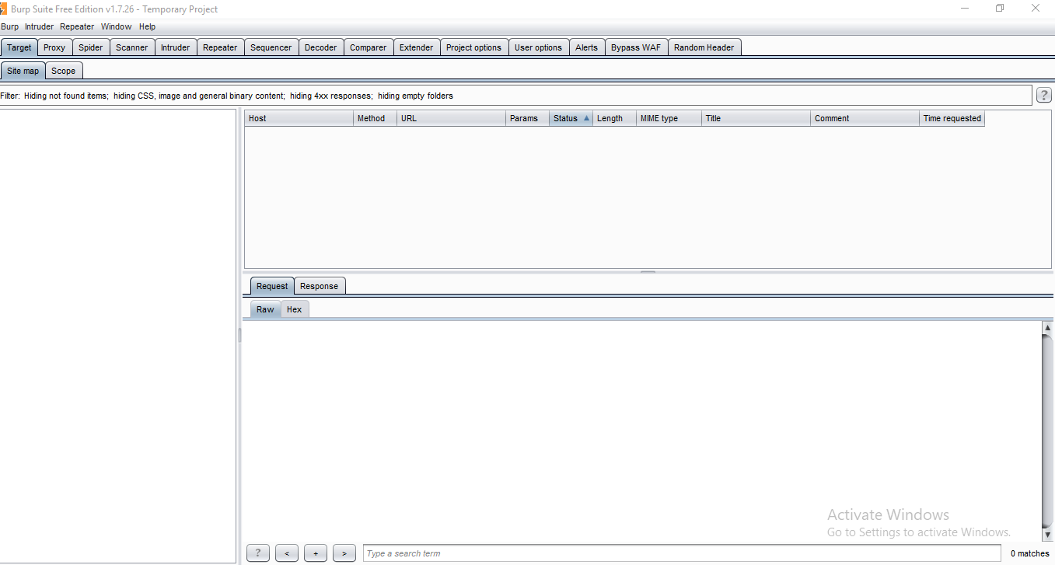

It is a web spider/crawler that is used to map the target web application. The objective of the mapping is to get a list of endpoints so that their functionality can be observed and potential vulnerabilities can be found. Spidering is done for a simple reason that the more endpoints you gather during your recon process, the more attack surfaces you possess during your actual testing.

**2. Proxy:**

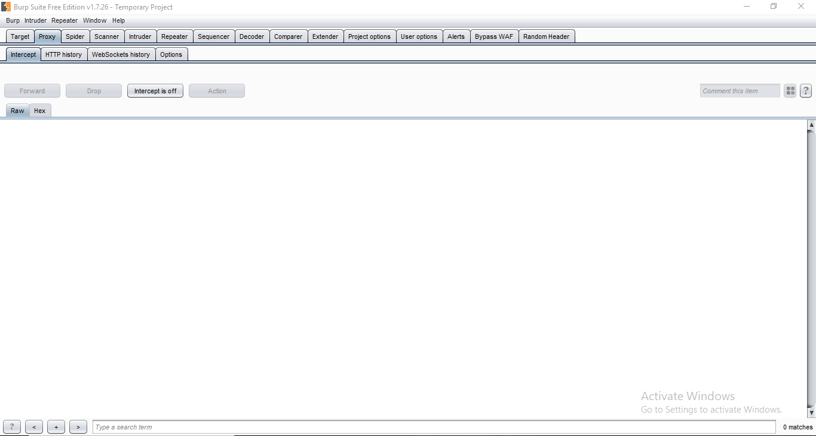

BurpSuite contains an intercepting proxy that lets the user see and modify the contents of requests and responses while they are in transit. It also lets the user send the request/response under monitoring to another relevant tool in BurpSuite, removing the burden of copy-paste. The proxy server can be adjusted to run on a specific loop-back ip and a port. The proxy can also be configured to filter out specific types of request-response pairs.

**3. Intruder:**

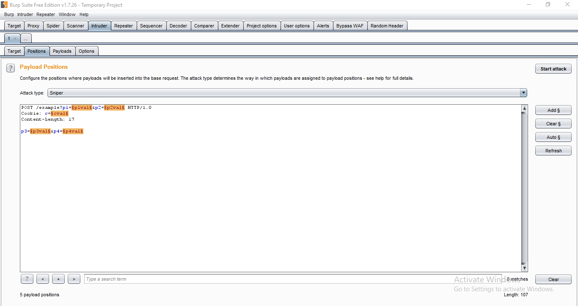

It is a fuzzer. This is used to run a set of values through an input point. The values are run and the output is observed for success/failure and content length. Usually, an anomaly results in a change in response code or content length of the response. BurpSuite allows brute-force, dictionary file and single values for its payload position. The intruder is used for:

* Brute-force attacks on password forms, pin forms, and other such forms.
* The dictionary attack on password forms, fields that are suspected of being vulnerable to XSS or SQL injection.
* Testing and attacking rate limiting on the web-app.

**4. Repeater:**

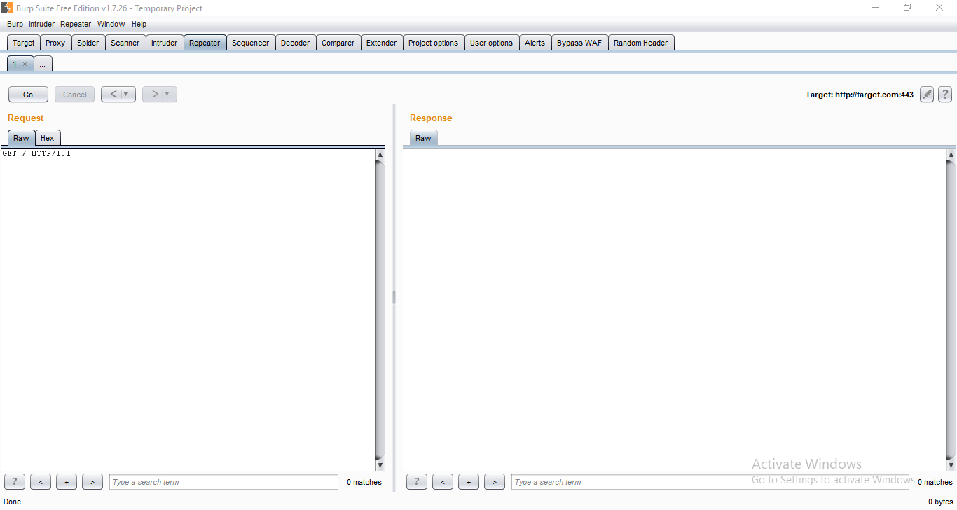

Repeater lets a user send requests repeatedly with manual modifications. It is used for:

* Verifying whether the user-supplied values are being verified.
* If user-supplied values are being verified, how well is it being done?
* What values is the server expecting in an input parameter/request header?
* How does the server handle unexpected values?
* Is input sanitation being applied by the server?
* How well the server sanitizes the user-supplied inputs?
* What is the sanitation style being used by the server?
* Among all the cookies present, which one is the actual session cookie.
* How is CSRF protection being implemented and if there is a way to bypass it?

**5. Sequencer:**

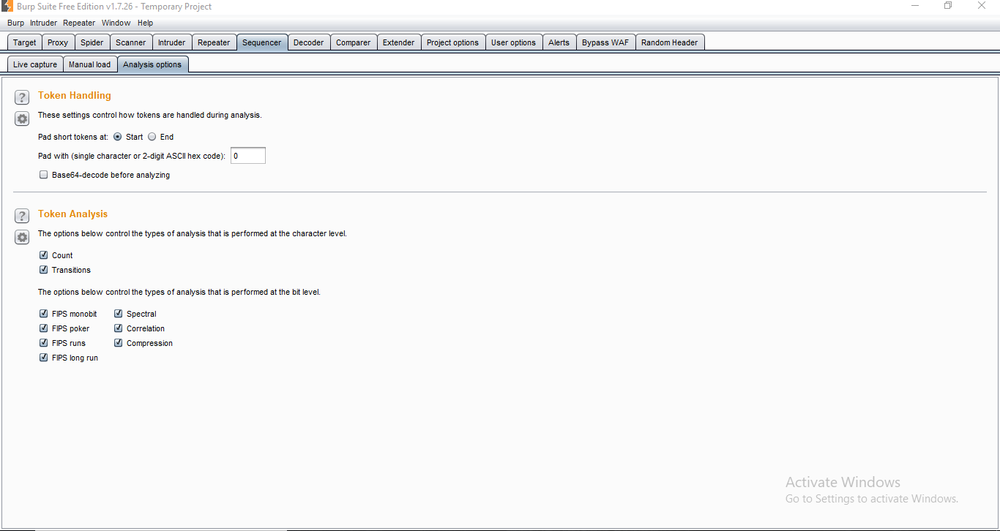

The sequencer is an entropy checker that checks for the randomness of tokens generated by the webserver. These tokens are generally used for authentication in sensitive operations: cookies and anti-CSRF tokens are examples of such tokens. Ideally, these tokens must be generated in a fully random manner so that the probability of appearance of each possible character at a position is distributed uniformly. This should be achieved both bit-wise and character-wise. An entropy analyzer tests this hypothesis for being true. It works like this: initially, it is assumed that the tokens are random. Then the tokens are tested on certain parameters for certain characteristics. A term significance level is defined as a minimum value of probability that the token will exhibit for a characteristic, such that if the token has a characteristics probability below significance level, the hypothesis that the token is random will be rejected. This tool can be used to find out the weak tokens and enumerate their construction.

**6. Decoder:**

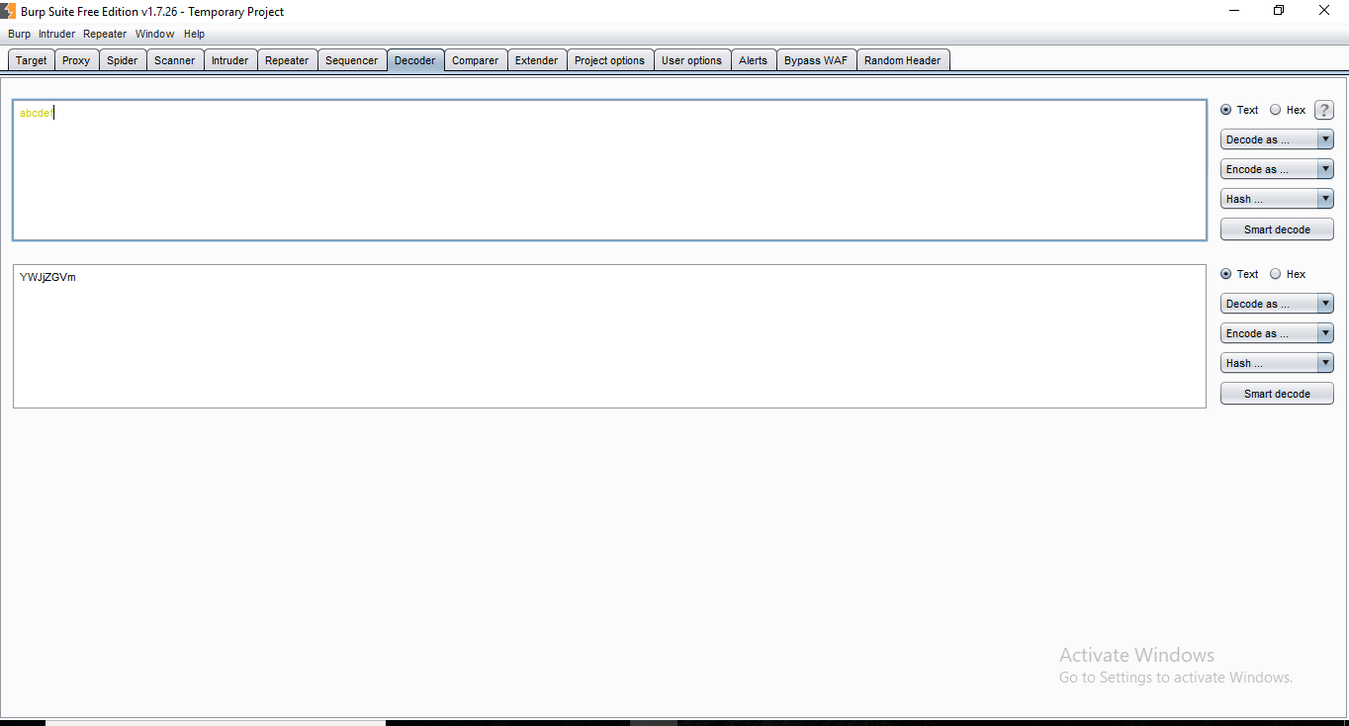

Decoder lists the common encoding methods like URL, HTML, Base64, Hex, etc. This tool comes handy when looking for chunks of data in values of parameters or headers. It is also used for payload construction for various vulnerability classes. It is used to uncover primary cases of IDOR and session hijacking.

**7. Extender:**

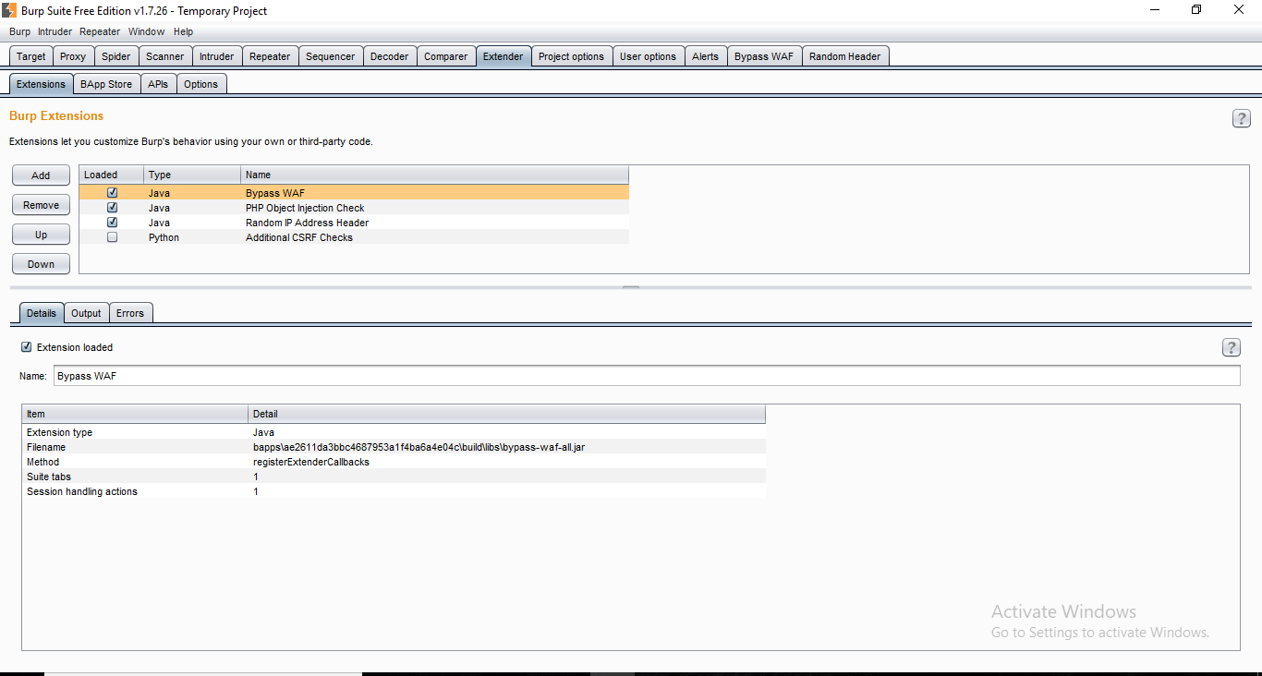



BurpSuite supports external components to be integrated into the tools suite to enhance its capabilities. These external components are called BApps. These work just like browser extensions. These can be viewed, modified, installed, uninstalled in the Extender window. Some of them are supported on the community version, but some require the paid professional version.

**8. Scanner:**

The scanner is not available in the community edition. It scans the website automatically for many common vulnerabilities and lists them with information on confidence over each finding and their complexity of exploitation. It is updated regularly to include new and less known vulnerabilities.

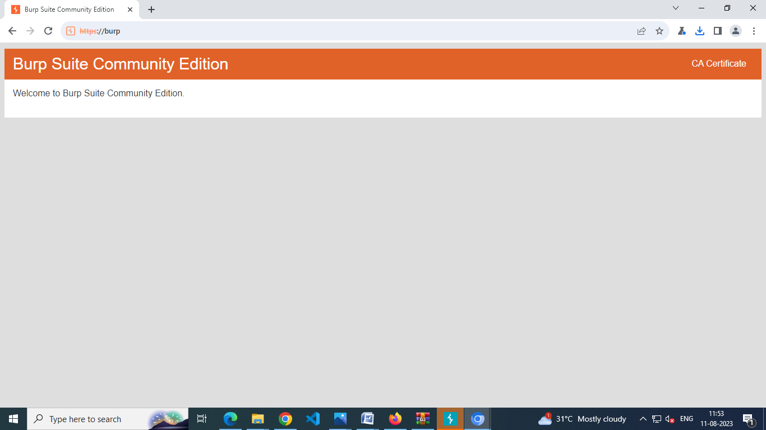

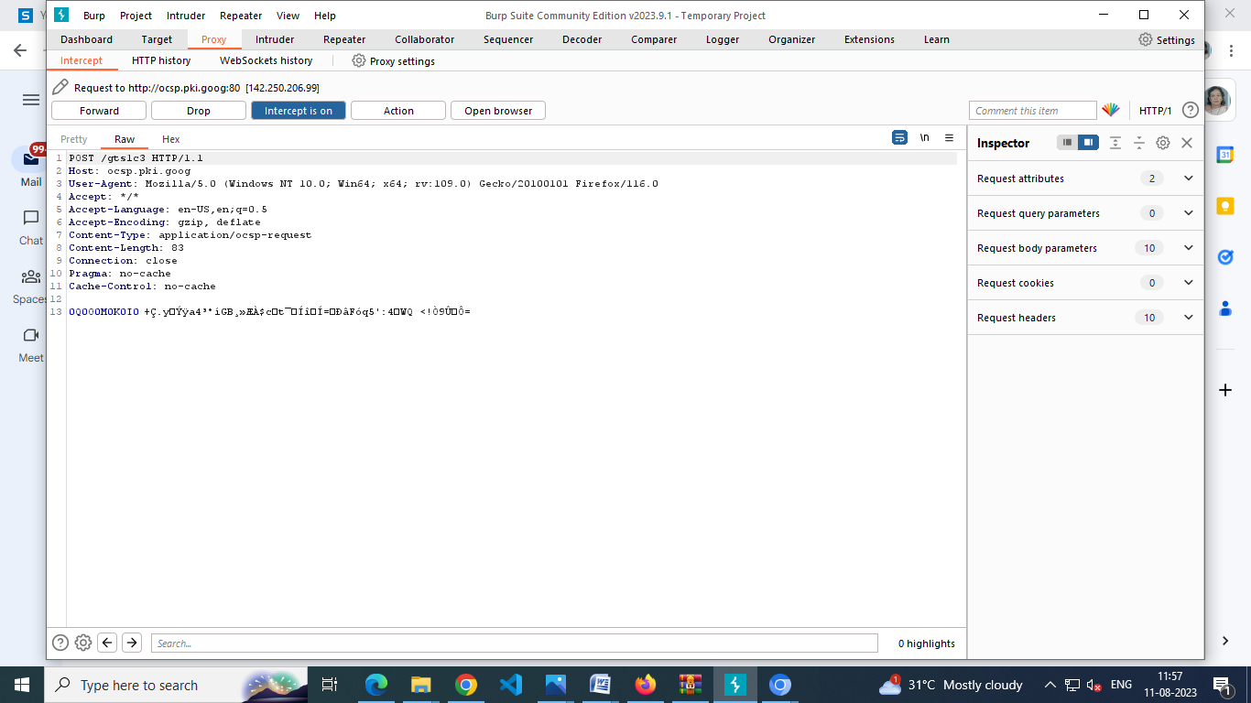

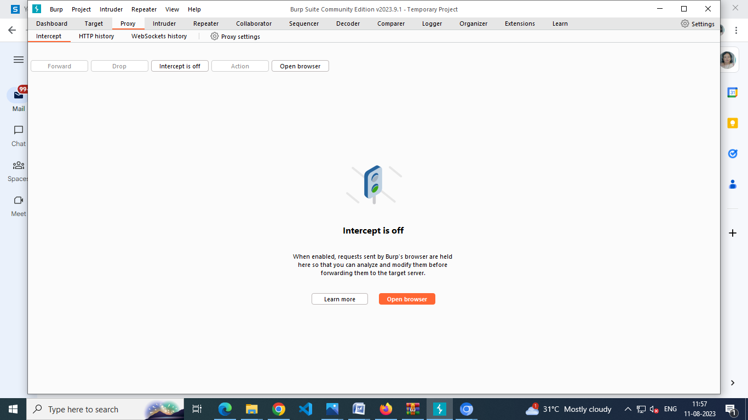

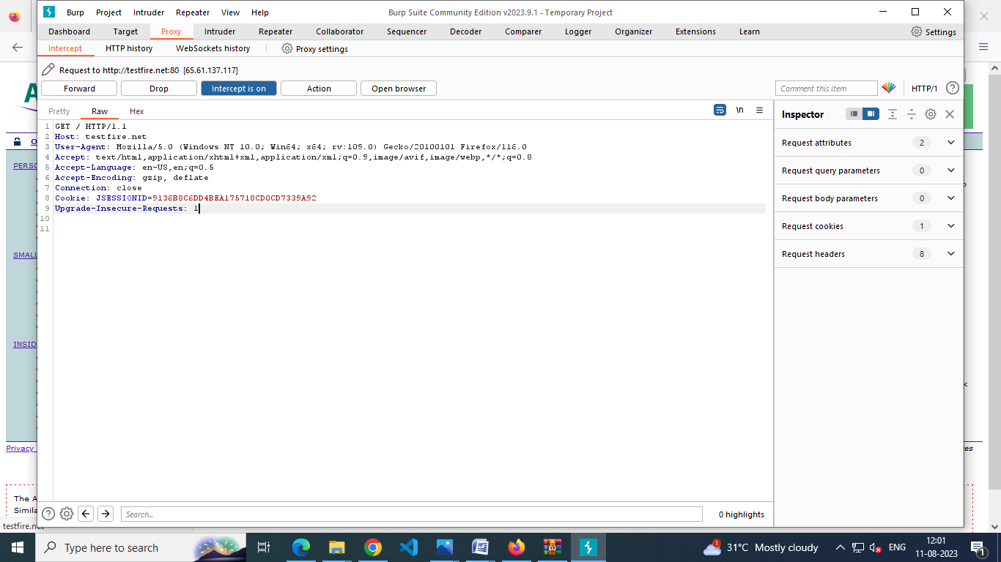

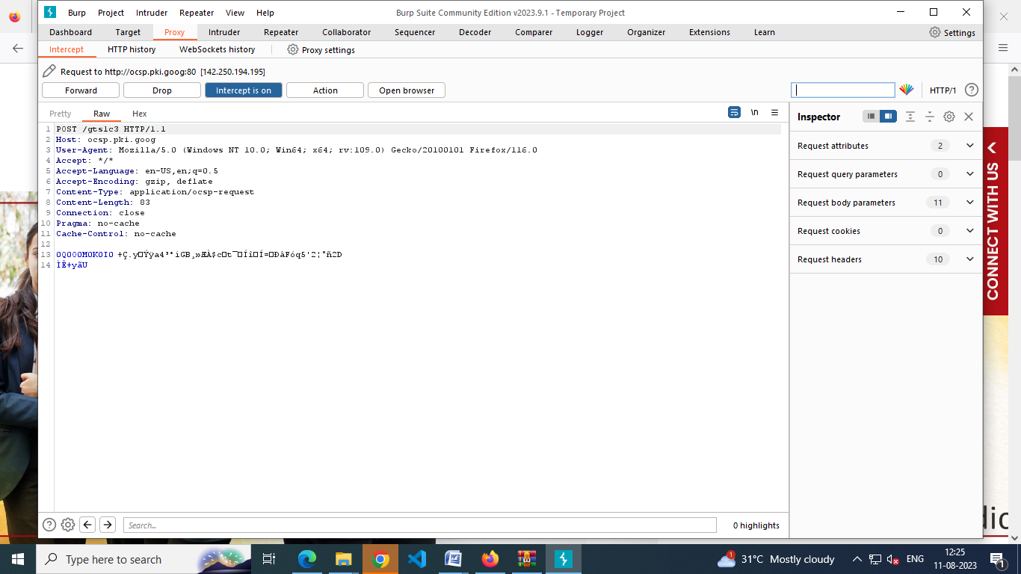

Target website: AltoroMutual testfire.net

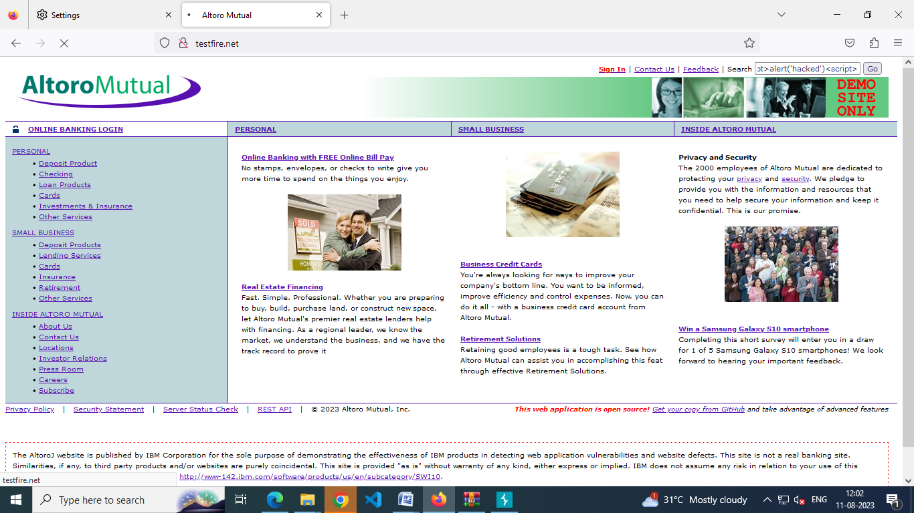

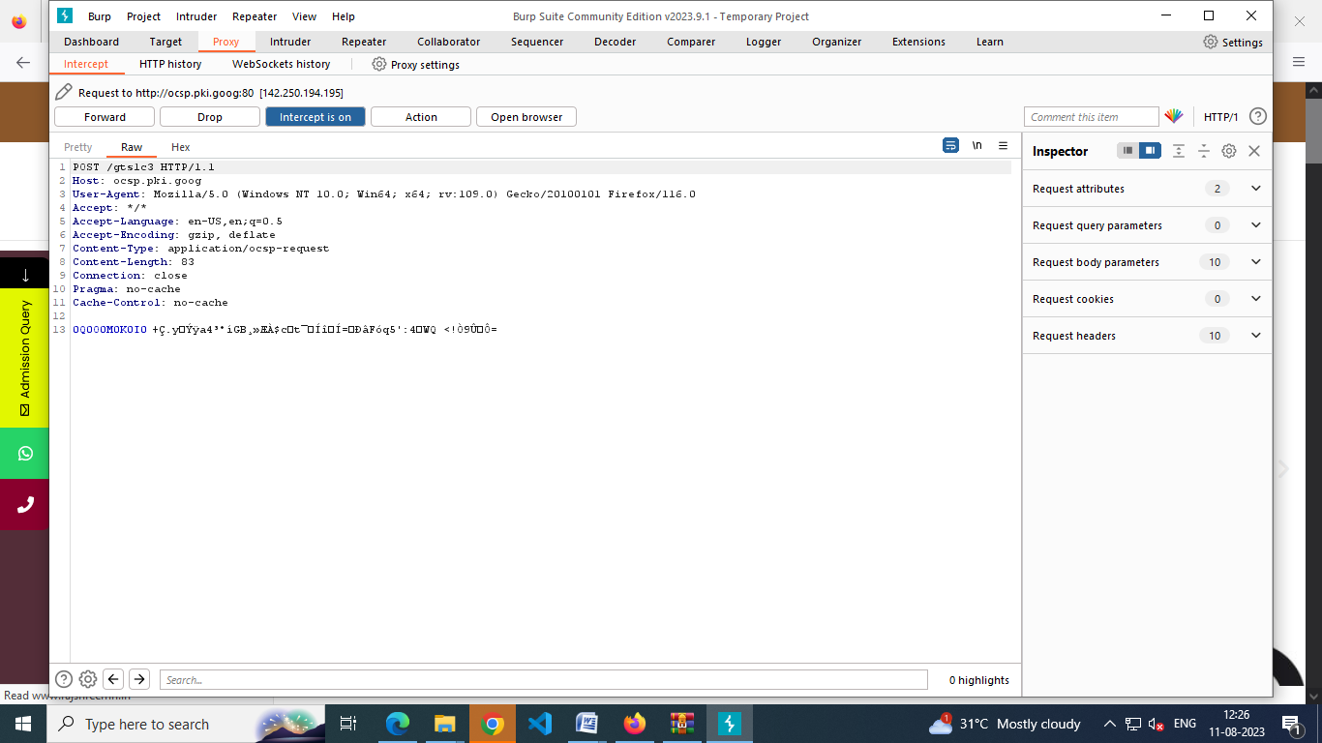

Target website: Rajshreemri.in

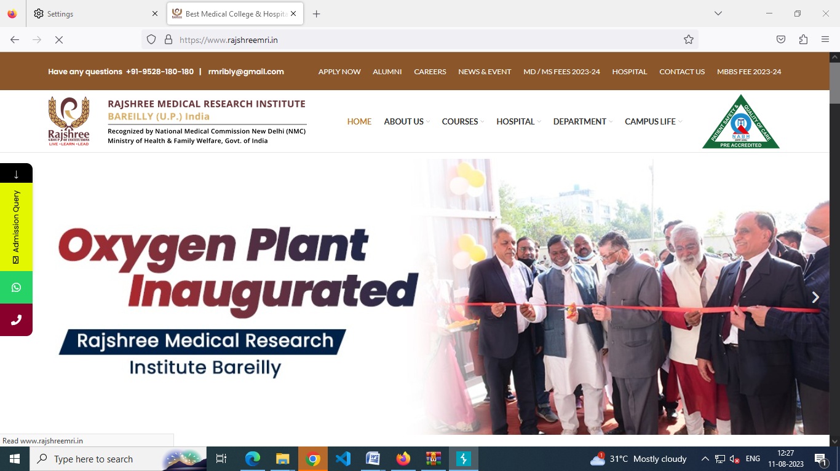

Target website: srms.ac.in



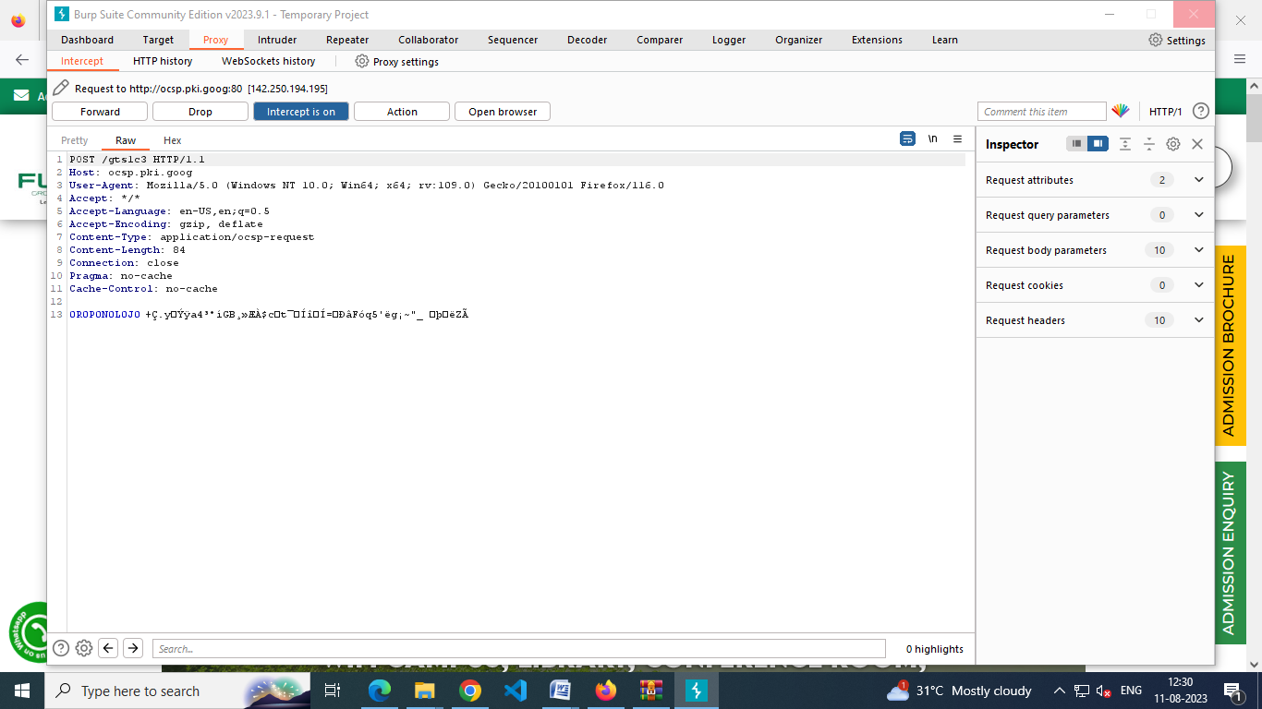

Target website: futureinstitutions.org



**STAGE 4: IBM QRADAR**

The IBM QRadar is a security information and event management or SIEM product that is designed for enterprises. The tool collects data from the organization and the network devices. It also connects to the operating systems, host assets, applications, vulnerabilities, user activities, and behaviors. IBM QRadar is used to perform analysis of the log data and the network flows in real-time so that malicious activities can be identified and stopped as soon as possible. Thus, the **main aim of the IBM QRadar is to prevent or minimize the damage to its host organization**.

**The IBM QRadar SIEM** uses a real-time integrated Cybersecurity AI, machine learning, and behavior analytics to prevent the attacks in the blink of an eye and with a very less cost compared to what human supervision can ensure. QRadar can address the bulk security issues that the companies face and save a lot of money. The security teams that struggle with patching endpoints properly and updating them can get their problems solved with IBM BigFix that has QRadar SIEM integrated into it. Most of the common issues are solved with this.

Deployment of the IBM QRadar SIEM is possible in the form of software, hardware, or a product meant for virtual application. Event processors for the collection, storage, and analysis of event collectors and event data make up the architecture of the product. They help to capture and forward the data.

There are flow processors as well that collect the network flows of Layer 4 of the OSI model. The Layer 7 application traffic gets a deep packet inspection through the QFlow processors. Management of SIEM can be performed by the SOC or Security Operations Center through centralized consoles. The flow processors are similar to the event processors, however, these are meant for network flows. The consoles offer a lot of help to the people who are managing or using the SIEM.

### Features of IBM QRadar SIEM

Let us look at an overview of the important features of the IBM QRadar SIEM.

* **Log activity**- Network events can be monitored and displayed in real-time and advanced searches can be performed through the IBM Security QRadar SIEM.
* **Assets**- QRadar SIEM automatically constructs the asset profiles by using the vulnerability data and passive flow data to discover the hosts and network servers.
* **Network activity** - The communication sessions between two hosts can be investigated with IBM Security QRadar SIEM.
* **Offenses** - Offenses for security issues can be investigated by QRadar.
* **Data collection** - Information in various formats is accepted by the QRadar SIEM from a vast category of devices that include network traffic, security events, and scan results.
* **Reports** - Custom reports and use default reports can be created in IBM Security QRadar SIEM.
* **Supported web browsers** - A supported web browser needs to be used to access all the features of the IBM Security QRadar.
* **Rules**- The QRadar SIEM rules are performed on the events, offenses, and flows. A response is generated by the rule if all the conditions of a test are met.

### QRadar Architecture Overview

The modular architecture of IBM QRadar can be used for prioritization and threat detection. The QRadar can be scaled to meet the flow and log collection. Integrated modules can be added to the QRadar platform like QRadar Vulnerability Manager, QRadar Risk Manager, and QRadar Incident Forensics. The operation consists of three layers and would apply to any QRadar deployment structure, and it is true regardless of the size and complexity.

#### Data Collection

The first layer is data collection where data like flows or events are collected from the network. Direction collection through the All-in-One appliance is possible. Collectors like QRadar QFlow Collectors or QRadar Event Collectors can be used for the collection of event data. The data gets parsed and normalized, and then passed to the processing layer. The parsed data is normalized to present in a usable and structured format.

The QRadar SIEM’s core functionality is based on a collection of data and flow. Event data represents those events that occur at a point in time in the environment like firewall denies VPN connections, user logins, emails, proxy connections, and other events that should be logged.

The flow data, on the other hand, represents network activity information between two hosts. QRadar translates them into flow records. QRadar would normalize and translate the data to IP addresses, packet counts, ports, and other information in the flow records. It represents a session between two hosts. Full packet capture is available with the QRadar Incident Forensics in addition to collecting flow information with a Flow Collector.

#### Data Processing

In the second layer, event and flow data are run through the Customs Rules Engine or CRE. This generates alerts and offenses which are written to storage. There are features like QRadar Vulnerability Manager, QRadar Risk Manager, and ORadar Incident Forensics to offer more functionality.

#### Data Searches

The data collected and processed by QRadar is available to the users for searches, reporting, analysis, and alerts of offense investigation. The users can search and manage the security admin tasks on the QRadar Console.

### SIEM working

IBM Security QRadar takes the log data from the log sources that are used by the applications and devices in the network and consolidates them. However, it is important to take note that the software versions for all the IBM Security QRadar appliances in a deployment must be having not only the exact versions but the same fix level.

### SIEM tools

The various tools under IBM QRadar help in data processing. The major ones are as follows.

* **QRadar Vulnerability Manager** - The tool scans the process and network vulnerability data. This data is used to identify the security risks in the network.
* **QRadar Risk Manager**- QRadar Risk Manager collects the network infrastructure configuration and provides a map of the network topology. The data can be used to manage risk by the simulation of network scenarios by implementing rules and altering the configurations in the network.
* **Radar Incident Forensics** - This tool performs in-depth network forensics and replays full network sessions.

### Benefits to using IBM QRadar SIEM

IBM QRadar SIEM is one of the best products when it comes to security management for an organization.

**Benefits of QRadar**

#### Complete visibility for the cloud and traditional environments

It is true that getting insight across multiple security environments can be tough. However, with IBM QRadar, you would gain centralized insight into the network events and data flow, be it an IAAS or SaaS environment

#### Elimination of manual tasks empowers the analysts

The analysts lose valuable time trying to manually track the processes. Thus analysts are often pulled from their work at hand. The product offers a solution that allows the users to see all the events related to a particular threat in a single place and eliminate the manual tasks so that analysts can focus on response and investigation.

#### Real-time threat detection

It is difficult to keep out an eye constantly for threats as it would be a good wastage of time and resources. The out-of-the-box analytics would investigate into the network flows and logs detecting threats and prioritizing general alerts and force the attacks into the kill chain.

#### Security capabilities

In addition to the basic SIEM capabilities, support is offered for the threat intelligence feeds. The license extension would have the IBM Security X-Force Threat Intelligence that would identify the URLs and IP addresses that are associated with malicious activity. A threat score and category would be given to each identified IP address or URL, which would help the organization prioritize threats and offer better analysis.

#### Reporting capabilities

IBM QRadar offers proper support for the major compliance reporting requirements initiatives like Payment Card Industry Data Security Standard, North American Electric Reliability Corporation, Health Insurance Portability, and Accountability Act, Federal Energy Regulatory Commission, and Gramm-Leach-Bliley Act. The product offers a report builder wizard for security teams to create custom reports.

The IBM QRadar is an amazing tool that can help organizations of any size to keep their data safe and secure. Integrating the tool in your system would definitely help you to secure all the data channels. The product would help to find the event and log data and keep them in specialized files for further analysis. The generation of alerts and proper measures would be the most important tasks that follow the analysis. The tool is one of the best security solutions today.

Steps for using QRadar:

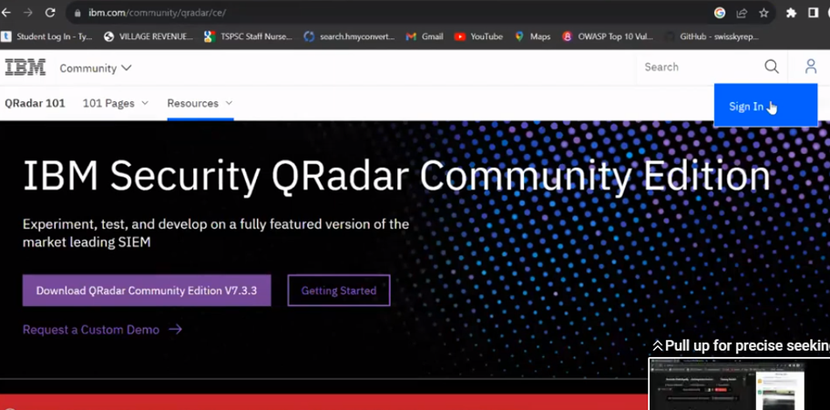

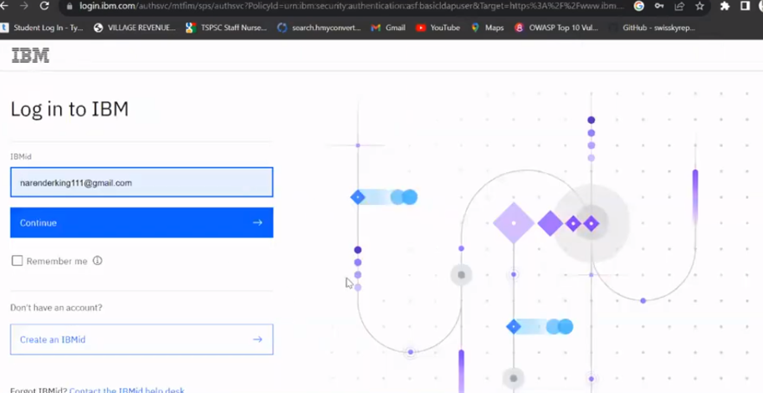

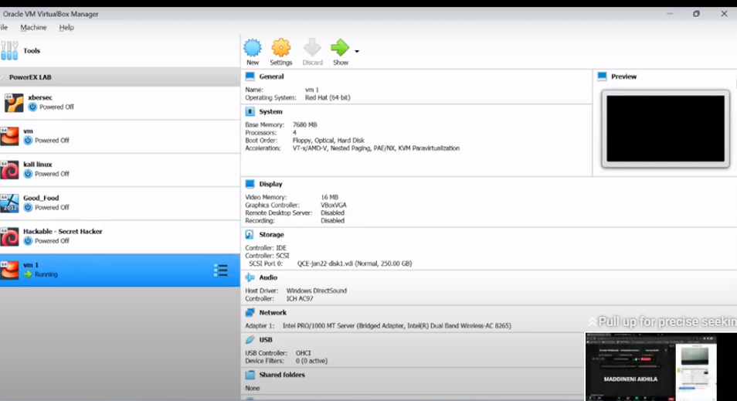



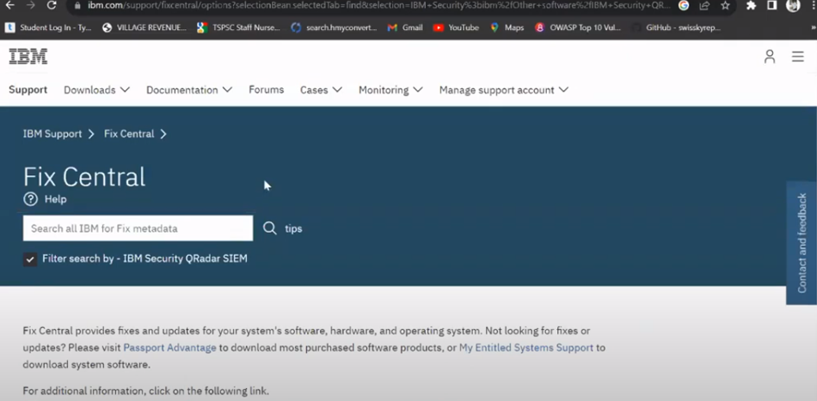

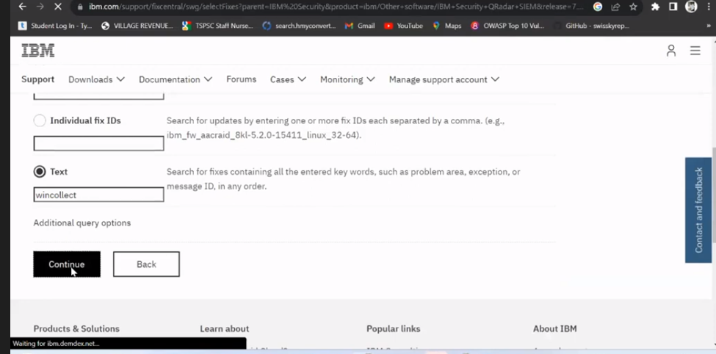

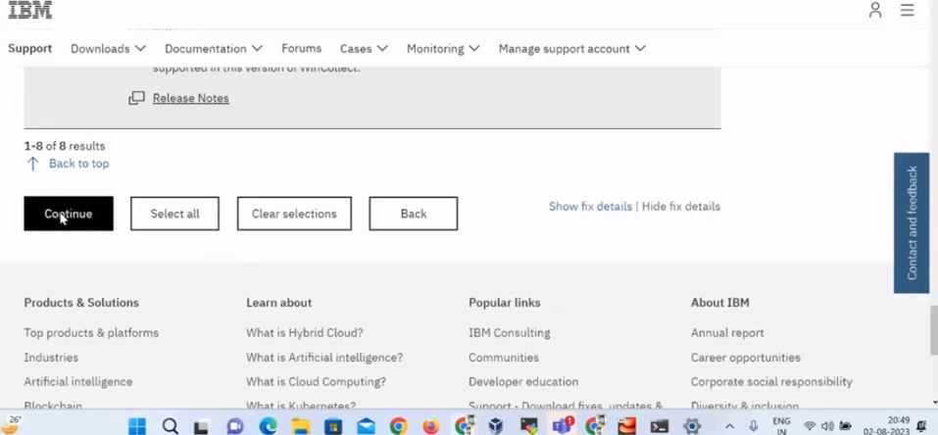

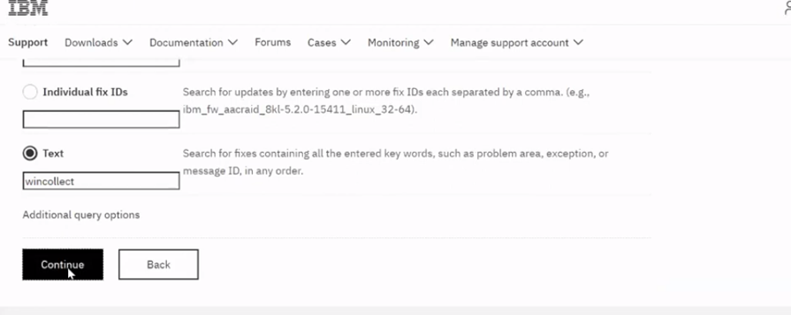

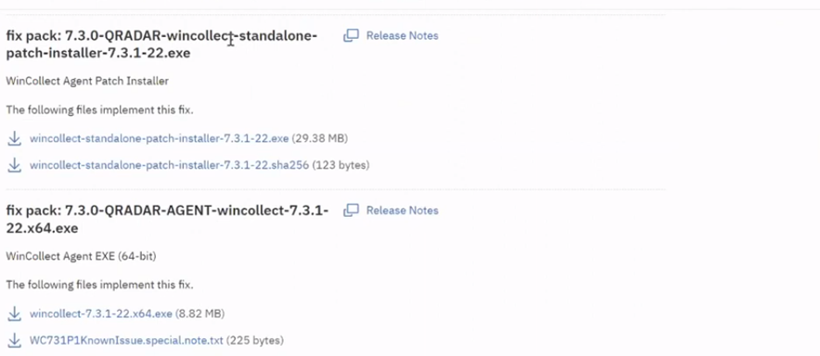

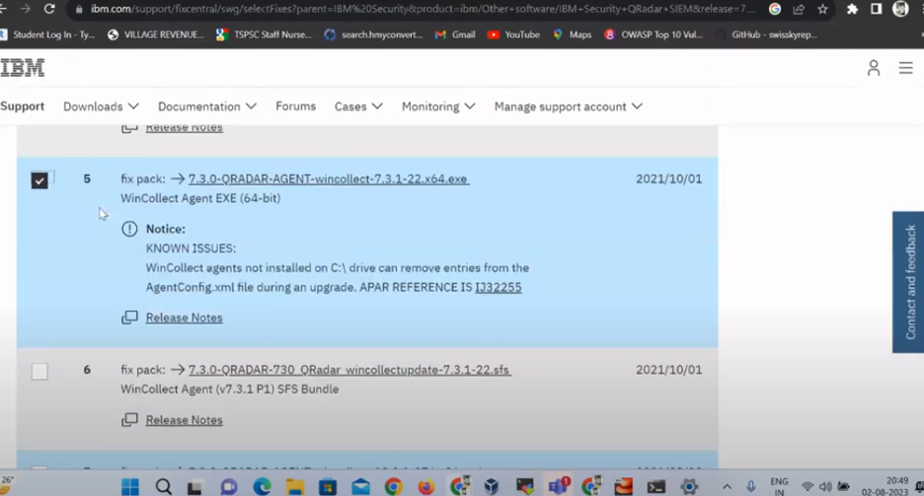

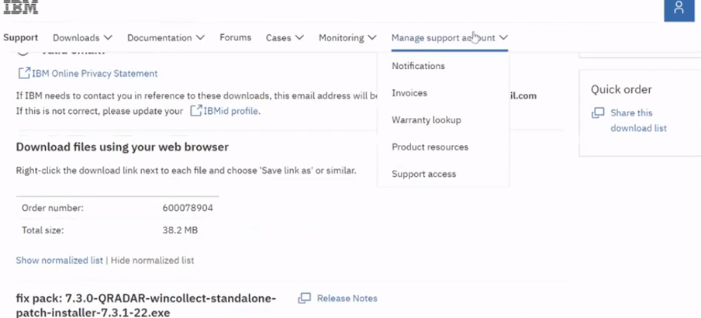

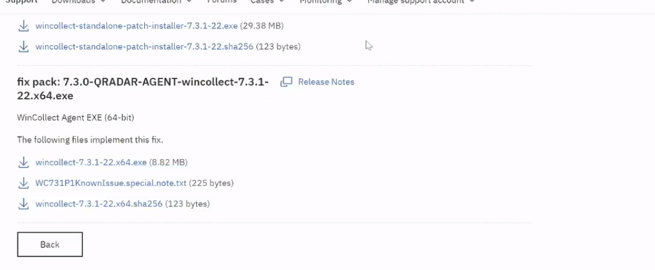

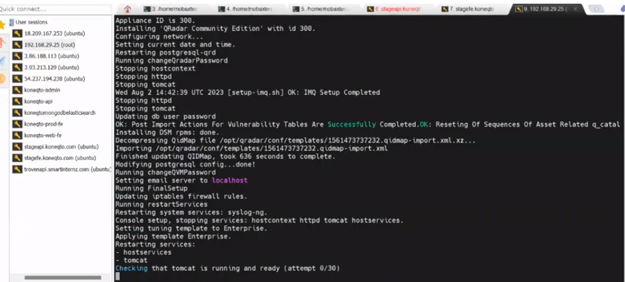

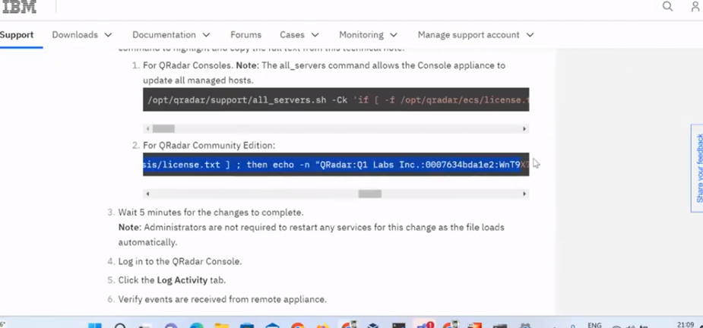

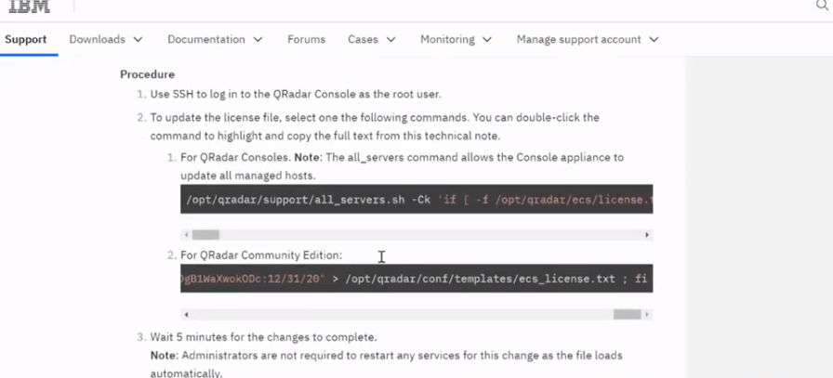

Stage 4 KALI LINUX 6.0.1 AND METASPLOITABLE 2

Operating System is the main system software which is responsible for the flawless working of the machine. Some Operating Systems are designed for some specific purposes. Though we could use them for anything we want to, but they have some special tools or services available feasibly to its users which makes it a good OS for the specific purpose. Kali Linux is a Debian-derived Linux distribution that is maintained by Offensive Security. It was developed by Mati Aharoni and Devon Kearns. Kali Linux is a specially designed OS for network analysts, Penetration testers, or in simple words, it is for those who work under the umbrella of cybersecurity and analysis. The official website of Kali Linux is Kali.org. It gained its popularity when it was practically used in Mr. Robot Series. It was not designed for general purposes, it is supposed to be used by professionals or by those who know how to operate Linux/Kali. To know how to install Kali Linux check its official documentation.

Advantages:

1. It has 600+ Penetration testing and network security tools pre-installed.
2. It is completely free and open source. So you can use it for free and even contribute for its development.
3. It supports many languages.
4. Great for those who are intermediate in linux and have their hands on Linux commands.
5. Could be easily used with Raspberry Pi.

Disadvantages:

1. It is not recommended for those who are new to linux and want to learn linux.(As it is Penetration Oriented)
2. It is a bit slower.
3. Some software may malfunction.
4. Kali Linux is to be used by those who are professional penetration testers, cybersecurity experts, ethical hackers, or those who know how to operate it.

In simple words, if you know how to use Linux and its terminal commands, architecture, system, and file management then you are good to go with Kali Linux. And if you are not, then we will recommend you first start with ubuntu distribution and get your hands on Linux and after sufficient practice, you could give Kali Linux a try. This will not only save your time of searching on the internet but also will make you use it with ease. However, if you’re a professional penetration tester or studying penetration testing, there’s no better toolkit than Kali Linux.

Kali Linux is just another Debian distribution with a bunch of networking and security tools. It is a weapon to train or defend yourself not to attack anyone. Kali Linux was designed mainly for professionals. It is for those who want to get their hands in Penetration Testing, Cyber Security, or Ethical Hacking. It is a powerful tool and in case, not used properly, it may lead to losses even.

